Meta Description:
YouTube marketing is a form of video advertisement that relies on video content to promote a brand through SEO, paid ads, and influencer collaborations.
Images Requirements:
https://drive.google.com/drive/folders/1cqPitu08AQMNn_ite3BVVqFoR6sEZzhH
Link to:
Youtube Marketing
https://threeanglemarketing.com/what-is-social-media-marketing-how-does-it-work/

What is YouTube Marketing and How to Do It in 2025?
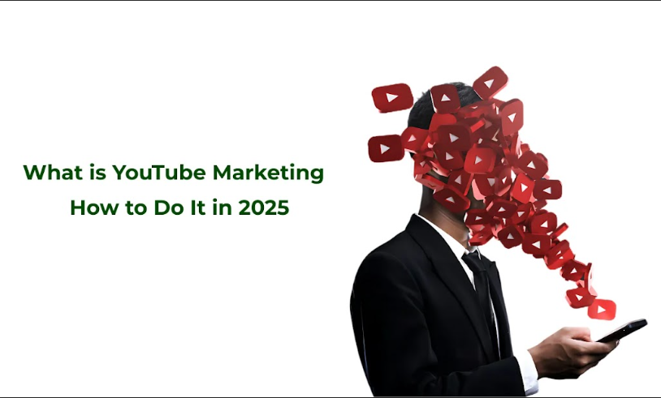
Having an adaptive mindset and policies is a requirement of modern times, especially when platforms and technologies are constantly changing.
In this unpredictable environment, YouTube continues to be a valuable ground for marketers who want to seek out a variety of customers globally.
Moving forward to the year 2025, the strategies of marketing through YouTube are even more diverse.
Now let’s look deeper at what kind of marketing YouTube offers, look at the types of videos, read more about the specifications of video advertising, and discuss why this platform is important for the development of your business.

1. What is YouTube Marketing?
YouTube marketing is the act of marketing goods, services, or brands on the YouTube platform with the aim of increasing impressions, interaction, and ultimately sales.
It is a strategic approach that involves matters concerning the production of video content for the clients, promotion of content, and advertising to potential clients. With technological advancement, YouTube marketing is expected to improve in 2025 and future years through the use of artificial intelligence in giving recommendations and aspects such as virtual reality.

Key Components of YouTube Marketing:
Let’s discuss the major components of YouTube Marketing that help you understand everything related to its working model:
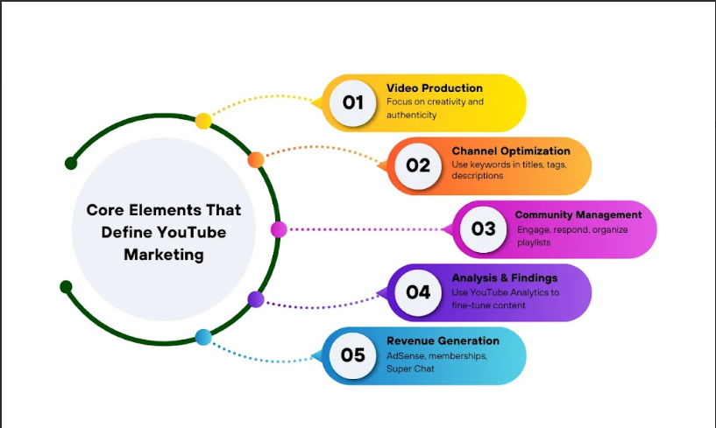
- Video Production: Produce compelling videos on given topics to your targeted clients. Consider the two most important values such as creativity and authenticity when it comes to grabbing people’s attention.
- Channel Optimization: This method is aimed at helping users improve their YouTube channel in terms of search and discovery. This compelled the end users to use relevant keywords on video titles, descriptions, and tags.
- Community Management: Always reply to comments, contribute to the videos by making playlists, and become active in the community.
- Analysis and Findings: You can check the performance of your strategies through YouTube analytics. In return, analyze data in order to fine-tune strategies as well as enhance the effectiveness of content.
- Revenue Generation: Include AdSense, becoming a member, and supercharge the generation of revenues from the content you post.

2. Trending Video Formats in 2025
The following are some of the types of videos that can help you find your YouTube account. It is crucial to know these formats to pave the way to a flexible content marketing method.
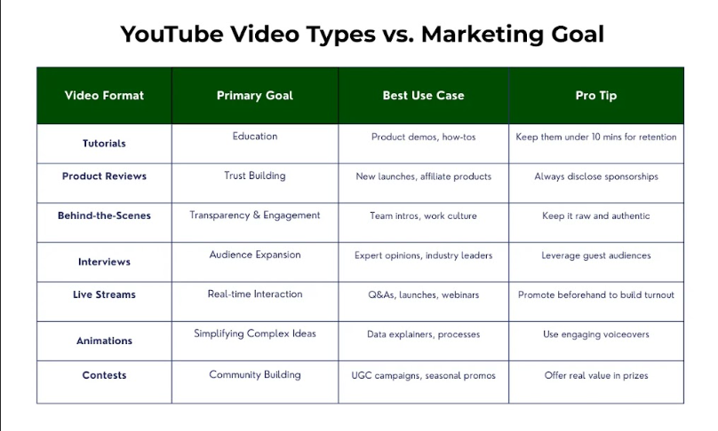
These videos are on a certain topic with instructions demonstrated on how to complete the particular activity. Let’s discuss trending video formats that will help you outsmart your competitors with ease:
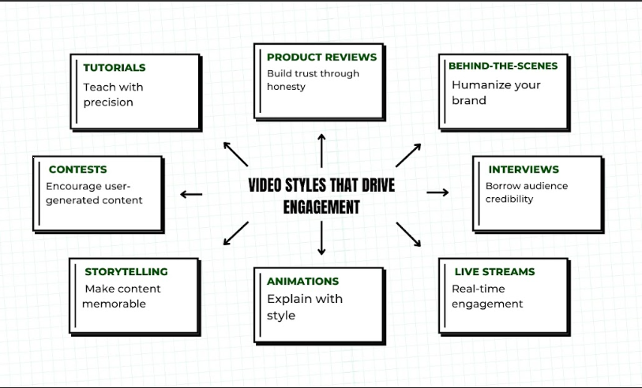

Tutorials:
Similar to guides but less general, these are information-rich and provide substantial information.

Product Reviews:
The provision of genuine and elaborate opinions of products wins customers’ trust. Every time, authenticity must be the gospel truth because this is the only way that you will be able to excel in such a format.

Behind-the-Scenes:
Give your audience a glimpse into your business or creative process. The difference between the simplistic and informative presentations of the corresponding materials is that these videos make your brand more personal.

Interviews:
Asking opinion leaders or popular individuals on particular topics in your niche may help in getting useful information and attracting the subscriber base of the invited person.

Live Streams:
Engage with your audience in real time through live streaming. It also helps in creating direct contact with the viewers, which may raise their interest in the program.

Animations:
Use animation in a project to explain something in the simplest manner or to present your project in an artistic and attractive way. Animation videos have better viewability rates than non-animated ones.

Storytelling Videos:
Details on how people can record videos that tell a good narrative that attracts the attention of the watchers. The use of stories in building a brand and engaging the audience is an effective strategy.

Contest:
Call your customers to develop content related to your brand. Sharing user-generated content fosters community and authenticity.

3. YouTube Video Ad Specs & Placements
YouTube ads have become a popular and effective strategy for reaching out to many people through YouTube. In 2025 and beyond, there will be improvements in the targeting of advertisements and formats for the advertisements as well. That’s why, it is essential to pay attention to the specifications of an advertisement as well as those of an advertisement placement.
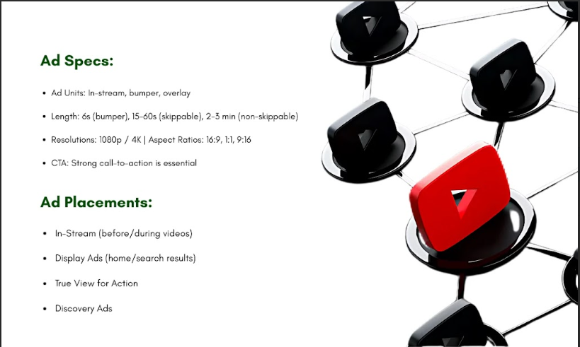

Key Ad Specs to Consider:
Just check out what you need to consider in your ad specs and how it can help your business.
- Ad Units: Get to know the typical YouTube advertisement forms, such as in-stream advertisements with or without the option of being skipped and bumper advertisements as well as overlay advertisements. Each type has certain peculiarities which give it advantages over others.
- Ad Length: Determine the appropriate ad length for your campaign. As for the type of ads, there are stationary and bumper ads that are more suitable for short messages, while there are lengthy ads to provide detailed information.
- Resolution and Aspect Ratio: It is important not to violate the resolution or aspect ratio that YouTube recommends to its users. Common aspect ratios include 16:9, 1:1, and 9:16.
- Call-to-Action (CTA): Always place a clear and attractive CTA in your ads so that it can persuade more users to convert.

Effective Ad Placements:
Now, let’s consider the aspects of effective ad placements
- In-Stream Ads: Place ads before, during, or after YouTube videos. These are among the most popular ad formats, giving much exposure to advertisers.
- Display Advertisements: Ads used on the YouTube Homepage, search result page, or on partner sites with the goal of raising awareness.
- TrueView for Action Ads: Ads are intended to generate a certain call to action to purchase a product from the ad.
- Discovery Advertising: This can help you reach your target audience and gauge their interest in your channel and any video you wish to popularize.

4. Significance of YouTube Marketing for Your Business
As for 2025, YouTube marketing still plays an important role in the overall marketing activity of companies. Let’s consider the significance of YouTube marketing for your business by taking into consideration the audience it covers, how to keep its consumers interested, and deliver actual results for your company.
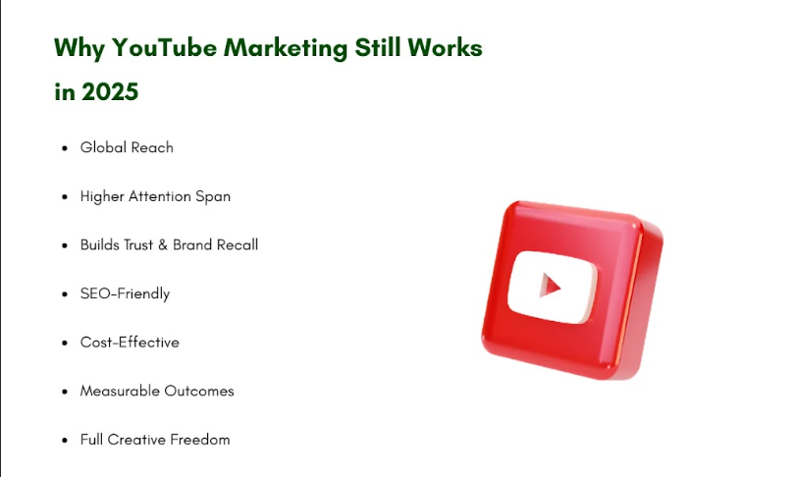

Awesome Audience Potential:
YouTube has its users in almost all parts of the world where men and women with internet access can be found.

Increased Interest:
Getting the attention of an audience through videos is easier than using other forms of content. This has the advantage of grabbing the attention more than the use of text or images to convey the message. So, through YouTube, you can engage with more people.

Brand Awareness and Trust:
By posting the information regularly and accurately, you can easily develop brand preferences and trustworthiness among your audience. Viewers like and trust the brands when a brand becomes personalized with them.

SEO Benefits:
YouTube is among the largest search engines in the world. In this case, optimized video content is one of the best ways of ranking highly to drive organic traffic to the channel.

Cost-Effective Advertising:
Advertising through YouTube is less costly compared to traditional media. It provides accuracy in targeting, so you can market your products to the intended target market.

Tangible Outcomes:
YouTube gives measurable reports to give meaningful data pertaining to advertisement impressions and viewer response. This data-driven approach surely helps you to refine your strategies for better results.

Full customization:
YouTube allows for a rather vast list of options regarding the content provided. From short videos to extensive ones, YouTube offers different options for the audience that have other preferences or goals to achieve in a particular campaign.

How to Create a YouTube Strategy in 2025?

In 2025, the digital marketing trends will be even more dynamic. Taking into account YouTube's role as one of the major video-sharing sites, it appears to be an essential way to communicate with viewers globally.
Creating a great plan on how to succeed on YouTube in 2025 requires embracing new trends, using new technologies, and relating well with the target market. Below are some great tips to assist you in achieving a proper plan for a successful future on YouTube.
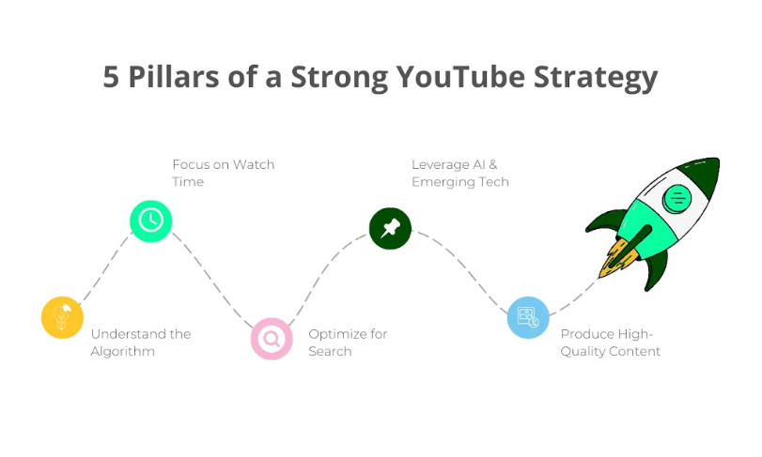

Understand the YouTube Algorithm:

Stay Updated:
YouTube's algorithm is a fluctuating one that undergoes change quite often in order to improve the experience of the end-user. In 2025, it is equally important for you to be on the right side of knowledge regarding changes. You need to constantly check the YouTube official blog and some of the reputable SEO news blog sites.

Focus on Watch Time:
Time-watched is one of the prominent metrics that has a motivational value for the YouTube algorithm. The flow of content in 2025 should focus on holding the attention of the viewers. By making creative and quality work that helps you to attract the target viewers, you can bring your audience to watch your videos till the end.

Optimize for Search:
Understanding YouTube SEO is essential. Ensure you use proper keywords in your video titles, descriptions, and tags so that your videos can be easily located by users interested in the subject. Perform keyword research using free tools such as TubeBuddy or VidIQ to come up with the keywords that are popular on the platform.

Leverage Emerging Technologies:

AI and Machine Learning:
With the use of these technologies like AI and machines, you can easily perform your content creation and analysis process. Employ AI solutions for improving the editing of your videos, recommending which videos to play next, and gathering more viewing statistics. Other free technologies as Synthesia or Lumen5 will assist in the creation of a video without spending much time.

Virtual and Augmented Reality:
Considering these couple of aspects, it can be concluded that the future of viewer experience is in VR and AR technologies. The following elements might be used in the content preparation in 2025: In other words, VR is a more suitable option for delivering particular stories, while AR allows your audience to actively participate in it.

Create Compelling Content:

Know Your Audience
Understanding your audience is fundamental. Polls, review comments, and checking the overall activity can help you determine the viewers’ opinions and further engagement. Cater to their needs and expectations to be in a position to offer benefits of optimizing their impact.

Diversify Your Content
In 2025, you should broaden your content network. When selecting the type of videos that you can upload to your YouTube channel, you can try different types of videos. For example, you can use instructional videos, vlogs, reviews, and livestream methods to diversify your content. It can also assist in satisfying the different customer demands and not make your channel monotonous.

Storytelling
The art of storytelling never gets old, as it is among the best ways of delivering a message to the targeted demographic. By creating stories, you can easily emotionally hook your viewers. Regardless of the nature of the article, whether it is a travel blog, a manual, or a book review, the incorporation of an interesting story is likely to attract more attention.

Engage with Your Audience

Build a Community
Creating a sense of community is very important. People’s suggestions and opinions have to be appreciated by permitting them to comment on the video, have a live chat, or share the video on social media platforms. Always reply to comments positively within a short time to encourage healthy discussions which leads to the development of a devoted readership.

Collaborate with Others
One of the benefits of collaborating is to expose your channel to other niche markets. You can collaborate with other YouTubers, influencers, or any form of companies that relate to your content. Such a partnership can be useful and interesting because it offers a fresh point of view in terms of ideas for the channel.

Utilize YouTube Shorts
YouTube is the latest to launch a short-form video, which is still growing popular in 2025. Ensure that the content you post is something that gripping to viewers. If you want to get more subscribers, you should include Shorts in your plans.

Optimize Your Channel

Professional Channel Design
Make sure your channel’s appearance is professional, if you want to attract the confidence of viewers. Aim at having a good logo, matching colors, and a catchy banner. Your channel description must be less complex or cheesy but it must be straight to the point and give an idea of what is to be expected in the channel more. So, ensure you integrate the relevant keywords.

Playlists and End Screens
You should organize your videos into playlists to help your viewers easily navigate through the numerous content that may interest him or her and also encourage them to binge-watch. End screens are the final set of annotations that can be introduced for recommending other videos, playlists, or subscription prompts, thus keeping the viewer in your channel.

Analyze and Adapt

Monitor Analytics
Subsequently, watch the analytics daily to monitor the performance of your channel. Some elements can be related to commonly known views, watching time, retention rate, and engagement. These can be employed to optimize your approach and material.

Adapt to Trends
The digital landscape is ever-changing. To be always relevant and respond to new options and viewers’ tendencies. Use new content types, innovative technologies, and marketing techniques to embrace new ideas to capture the market.

Monetize Your Channel

Diverse Revenue Streams
It will be highly wise to administer multiple sources of income in the year 2025. Although you can also make around with other streams of income, including ads, channel membership, super chat, merchandise shelves, and affiliate marketing. The dispersion of the income streams emanating from different markets means that there is limited reliance on a single source of income.

Build Brand Partnerships
Working together with brands can help get funding and ensure your channel gains recognition among the target audience. To this end, it is advisable to look for partners with companies whose products match the content you offer or the people you target. This shows that there’s nothing as important as building trust with the viewers by only putting in genuine collaborations with the brand.

11 Pro YouTube Marketing 2025 Tips

Here is a list of 11 professional marketing tips for YouTube that you can use in 2025 and beyond for better results.
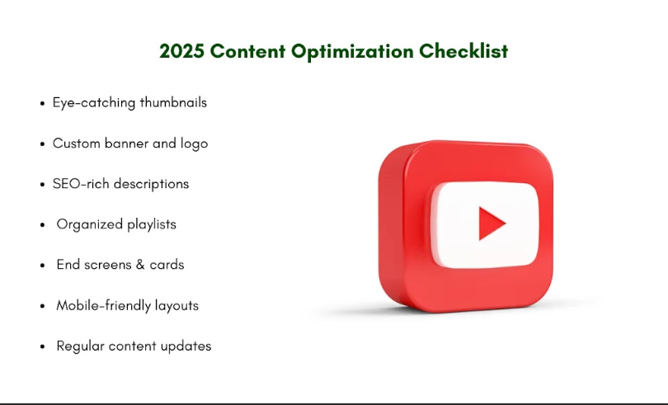

1. Optimize Your Channel for Search
Search optimization plays a crucial role as the main strategic element of marketing on YouTube. Optimizing your keywords for the title of your video, its description, as well as its tag is very important. To be at the top of your target audience’s mind, you need to do a proper search and find out what your audience wants. Tools such as VidIQ and TubeBuddy can help when it comes to finding target keywords. To enhance the chances of your videos being easily found, update your video descriptions with suitable keywords from time to time.

2. Create Engaging Thumbnails
First impressions are very important, and thumbnails are exactly the first thing that viewers notice. Choose the freedom of choice and upload bright and sharp images that will reflect your video’s idea. When picking popular stories, it is advisable to use highlighted texts, bright colors, and provocative images to encourage people to click on them. You can create professional thumbnails using simple software such as Canva and Photoshop.

3. Leverage YouTube Ads
Advertising on YouTube is an excellent idea to expand its outreach. You can use Google Ads to run specific campaigns with some targeting set on demographics, interests, or observed behavior. On the YouTube advertising platform, you can set prices and their eyelids, target options, and get an overview of the campaign results.

4. Utilize Playlists for Engagement
In general, playlists are one of the most effective ways to extend the viewer’s average time spent watching the material and repeated perception of the content. Continue creating playlists based on certain topics and episodes to retain the audience’s interest. Provide your viewers with some guidance with regards to the order in which they should watch the videos so that they are most likely to binge-watch. This not only helps the users to have a better experience on your site but also informs YouTube that your content is worthy of its popularity.

5. Engage with Your Audience
Community building around the channel is highly important for success. Respond to comments as soon as possible, actively encourage viewers to contribute further comments, and post content relevant to the comments posted by the viewers. Objective questions and polls can be used in the descriptions of videos with the aim of encouraging engagement.

6. Collaborate with Other Creators
The collaborations also help in increasing the number of subscribers to the target channel. Cooperate with like-minded producers whose target audiences are similar but do not coincide with the ones you are targeting. This can happen in terms of guest appearances, production of collaborative videos, or promotion of each other's products. The concept of virtual working can be achieved through tools and services for effective collaboration, such as Zoom and Google Workspace.

7. Automate Your Workflow
One of the most important factors that you need to consider while running any YouTube channel is productivity. Tools automate your tasks and help you save time on different operations that would usually take ages in the manually. Additionally, automation lets you work on the content aspect while handling people’s engagement on the platform adequately.

8. Analyze Performance Metrics
Knowing your performance indicators is a significant factor to improve on the strategy. Make it a practice of checking your YouTube Analytics frequently to monitor the views, watch time, audience retention, and engagement rates, among other factors. That data can be useful to analyze trends, viewers’ behavior, and make the right decisions.

9. Diversify Your Content
You can use different content formats to diversify the content with the use of tutorials, vlogs, live streams, and interviews. Hunt for fresh issues that are relevant to your brand, but at the same time, engage your major target market. In addition to the creation of diversity, diversification minimizes the risk of relying solely on a single genre of content.

10. Invest in Quality Production
High-quality production distinguishes a channel from competing with its rivals. To enhance your production quality, get quality equipment that applies to your type of show, for instance, cameras, microphones, and lights. Keep the audio portion clear and keenly pay attention to the video quality to achieve a professional outlook.

11. Stay Updated with YouTube Features
YouTube remains an ever-growing site that frequently updates features and offers new algorithms. Please be aware of the novelties to seize new opportunities. The most important sources of information are YouTube’s official blog, reading industry blogs, and active participation in YouTube creator communities.

Achieve Success with YouTube Marketing Tools: Paid, Free, and Automation

YouTube remains an enormous platform where content creators as well as marketers hope to take their content to reach out to many people. If you are ever to get the best of this important platform, you must embrace the right marketing tools. Here are paid, free, and automated tools that allow you to utilize all the features and opportunities of YouTube.

Paid YouTube Marketing Tools
The presence of such services in paid instruments can greatly help to improve your Internet marketing on YouTube. Most of these tools are rather useful and contain features that help you expand your audience and gain knowledge.

- TubeBuddy: TubeBuddy is an add-on for browsers and a tool for working with a YouTube channel, which makes it possible to optimize videos. This tool provides keyword suggestions, SEO advice, and thumbnail previews that may improve search results ranking.
- Rapportive: It is an excellent tool that social networking platforms can to analyze and measure the engagement activity of the YouTube audience. The knowledge of the audience will help you satisfy its needs and wants by presenting the content in a way that it will accept it
Performance tools are worth the cost as they ensure that you get value for your finances and get to grow a wholesome YouTube Channel, within a short period.

Free YouTube Marketing Tools
Here are 10 free tools that will assist you in achieving the goals of growing your YouTube channel.

- TubeBuddy: TubeBuddy is fully equipped with an essential element for instance, SEO, keyword, as well as other factors essential in your videos that are successfully conveyed in its free version.
- Canva: Provides options to create graphics, thumbnails, and video designs online with the help of graphic design tools. It is all-important to attract the attention of the viewers, and thankfully, Canva makes it possible for anyone to do that easily through the use of great visuals.
- Google Analytics: Linking your page with Google Analytics means a wealth of data about viewer interaction and traffic origin aids in the customization of content.
These tools can help you boost your channel without spending a lot of money, which will be greatly appreciated by channels created by small businesses or individuals.

Automation YouTube Marketing Tools
It helps you save time or avoid the repealing of efforts in content production by concentrating on the quality of the content.

- TubeBuddy (Automation Features): The other aspects of TubeBuddy include automation features, such as the ability to make SEO modifications, batch editing, and even scheduling of the videos.
- VidIQ: VidIQ has automated tools and unique features you can make use of to operate your channel, keyword optimize, and set engagement notifications. It assists you with constant posting and keeping in touch with your audience.
- FlixTerms: This tool can help you manage copyrights for songs used in your longer videos to guarantee that they are not against YouTube’s terms of service and will save you much of your time.
Always, automation tools can help in keeping the flow of materials on YouTube steady while the main business initiatives are being worked on.

Conclusion
Developing a unique strategy to market a product on YouTube in 2025 would involve the use of creativity, advanced technology, as well as a relationship with the target group. If you comprehend the algorithm, utilize the advances in different technologies, and learn from the results, you should be able to get to know how to enchant viewers and find a way to excel.
Before concluding, let it be noted that flexibility and creativity are the pillars of success in any environment primarily in the digital hemisphere. Follow and sustain these principles and your YouTube channel would be perfectly poised to ream in 2025 and beyond. For more information related to YouTube marketing, feel free to contact to Three Angle Marketing team any time soon.

